Ortiz Guzman, Julio

25 October, 2021

ECe 3200-01 Lab 9

High Frequency Performance of Common-Emitter Amplifier

**Objective:**

The objective of this lab is to measure the small-signal frequency response of a CE amplifier and to account for the outcome by the Miller effect consideration and support the analysis by Pspice simulation.

**Prelab:**

1. Design the CE amplifier shown in fig.1 so that ICq = 10 mA and the output ac resistance , Ro , is 470 Ω . Take IR1 =10IBq and IR2 = 9IBq for a robust DC stability and take VE = 2.7 V. Take β ≈ 100.
2. Determine the mid-band frequency small-signal voltage gain , Av = vo / vi , and the input impedance , Rin = vi / iin , of the amplifier.
3. Determine the input capacitance, Cin , of the amplifier using the Miller effect method . For this transistor the collector-to-base junction capacitance, Cμ (AKA Ccb) may be assumed to be approximately 8 pF and base-to- emitter capacitance, Cπ (AKA Cbe) may be determined from the equation,

Cπ = gm /2π fT - Cμ , where gm = ICq/ VT where fT is the unity-current gain frequency of the 2N2222A transistor (See ref. , CH 17.4). For 2N2222A fT may be assumed to be 300 MHz (search Web Datasheets). Take the thermal voltage VT = 25 mV.

**Procedure:**

1. Construct the circuit as shown in fig. 1 and make the following DC measurements:

VC = 7.51 V

VE = 2.68 V , VCE = 4.78 V , IC = (VCC – VC )/ RC = (12 – 7.51) / 0.47k = 9.6 mA.

1. Set vg = 15 mVpp by adjusting the signal generator amplitude to about 1.5 Vpp; the 1000/10 resistive attenuator will reduce the generator output by approximately 100 times
2. Measure the mid-band frequency (at 5 –10 kHz range) voltage gain, Av, the input resistance Rin­ and the output resistance Ro:

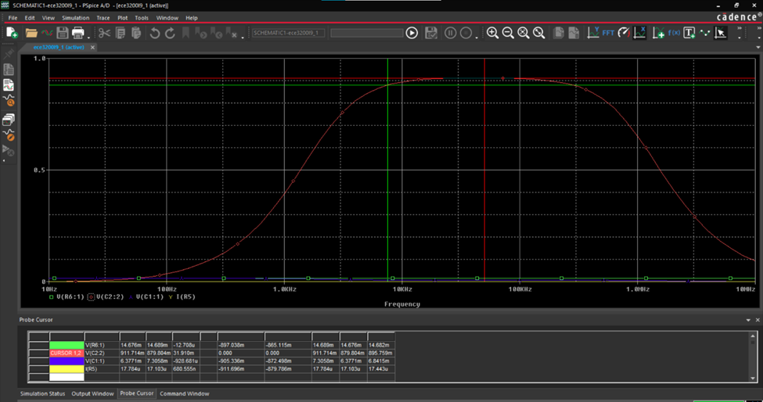

With RL = 470Ω connected,

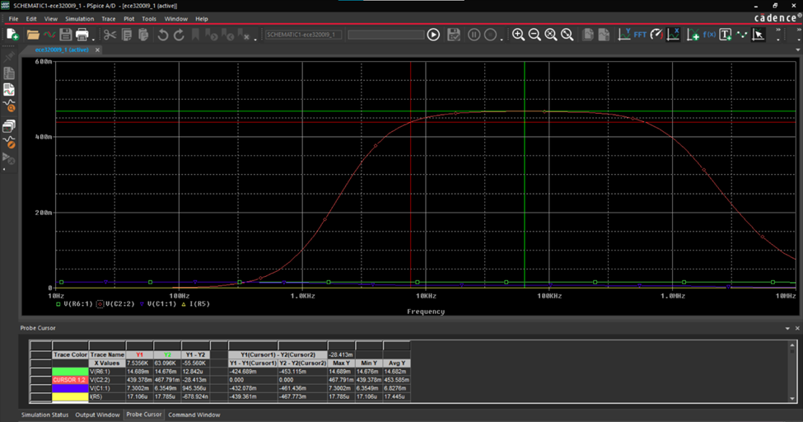

**Calculated Values:**

vg = 15 mVpp, vi = 7.4 mVpp , vo = 860 mVpp (no load), iin = (vg – vi)/ Rg = 16.17 μApp

Av = vo / vi = -116 , Rin = vi / iin = 458 Ω , Ro ≈ 470 Ω (Since vo drops from 860 mVpp to approximately 430 mVpp when an external load resistor of RL = 470 Ω is added).

**Measured Values:**

vg = 14.69 mVpp, vi = 7.3mVpp, vo = 880 mVpp (no load), iin = (vg – vi)/ Rg = 15.51 μApp

Av = vo / vi = -120 , Rin = vi / iin = 472 Ω , Ro ≈ 470 Ω (Since vo drops from 860 mVpp to approximately 430 mVpp when an external load resistor of RL = 470 Ω is added).

1. Now apply input signal and vary the frequency from 10 kHz to 10 MHz and graph the **“stage”** voltage gain , defined as **Ag = vo /vg** , versus the applied frequencies. Construct a table of Ag versus the frequency and specifically measure the –3 dB higher cutoff frequency point , fch,

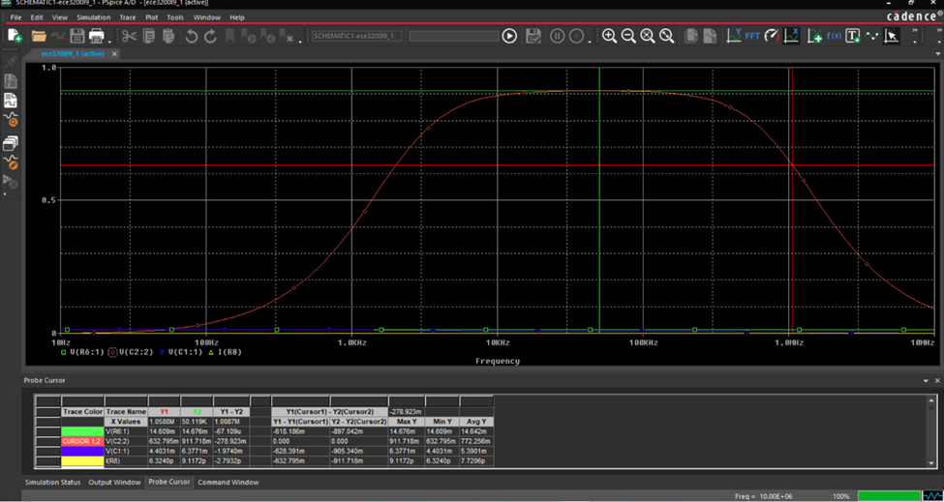

Ag = - 61 ….. Mid-band frequency stage (or overall) gain.

fch = …1.06M…….. From plotting the table.

Fig.1

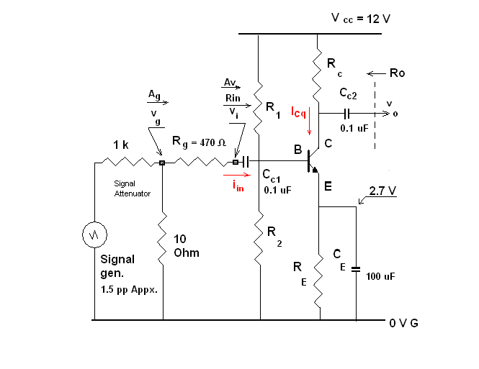

**Conclusion:**

As a result of this lab, I was able to better understand measuring the small-signal frequency response of a Common Emitter amplifier, specifically the high frequency response of said amplifier. I was also able to observe the Miller Effect applied on the circuit as shown by the almost bell-like curve. The voltage gain of a CE amplifier varies with the frequency. Although I was not able perform the lab physically, I was still able to visualize and understand the circuit with the help of pSpice, and the zoom meeting provided. An emitter bypass capacitor is in parallel with RE to provide low reactance to the AC signal. The reactance of the coupling capacitor is relatively high, thus small parts of the signal will pass from the amplifier stage to the load. As a result, CE cannot shunt the RE because of its large reactance at low signal frequencies. This would cause a drop off voltage gain at lower frequencies, however, in this lab we also see that the voltage gain again drops off at extremely large frequencies.